EXPERIMENT 6 PAYROLL

Step1: Create an application called ‘PayRoll Processing system’

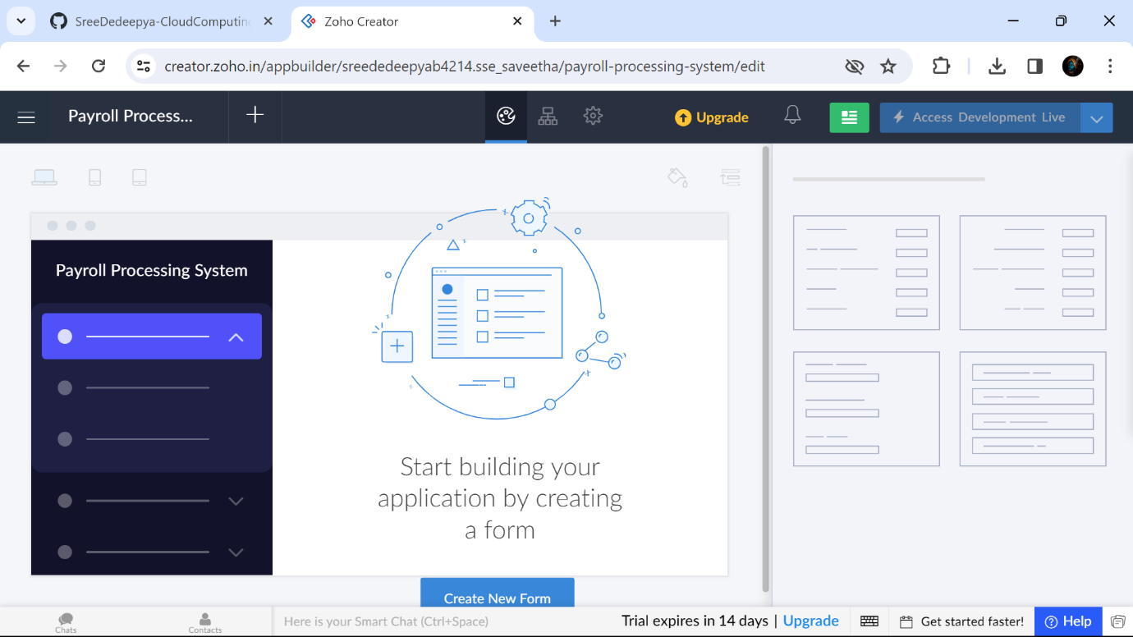

Step2:Create a form called ‘Employee Details’

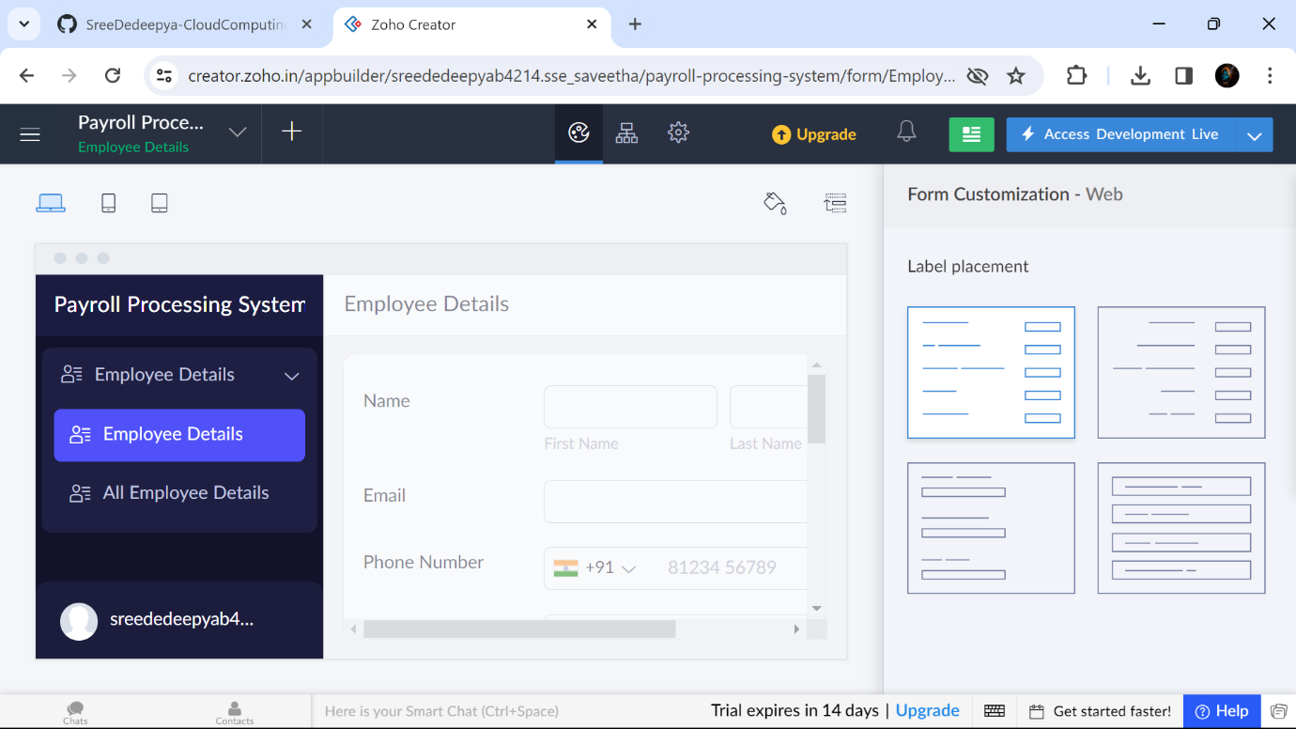

Step3:Create a form called ‘Organization Details’

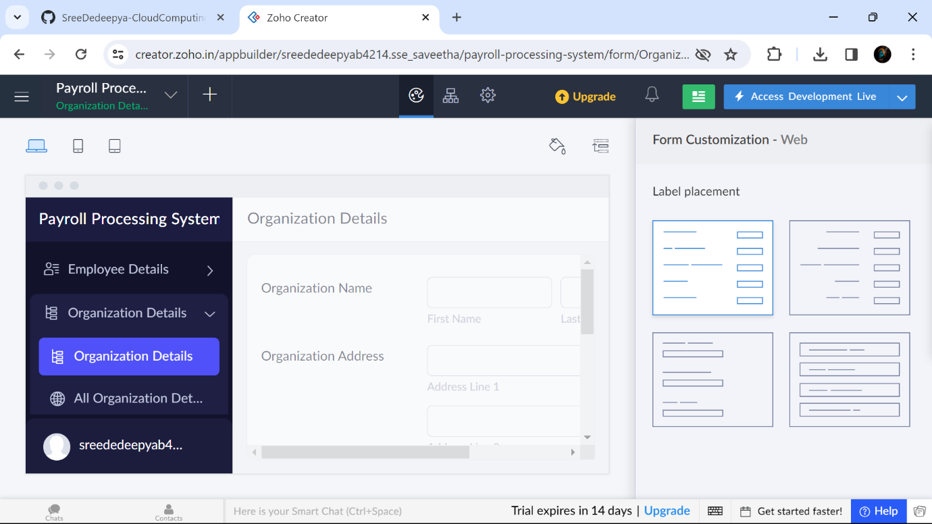

Step4:Create a form called ‘Payment Details’

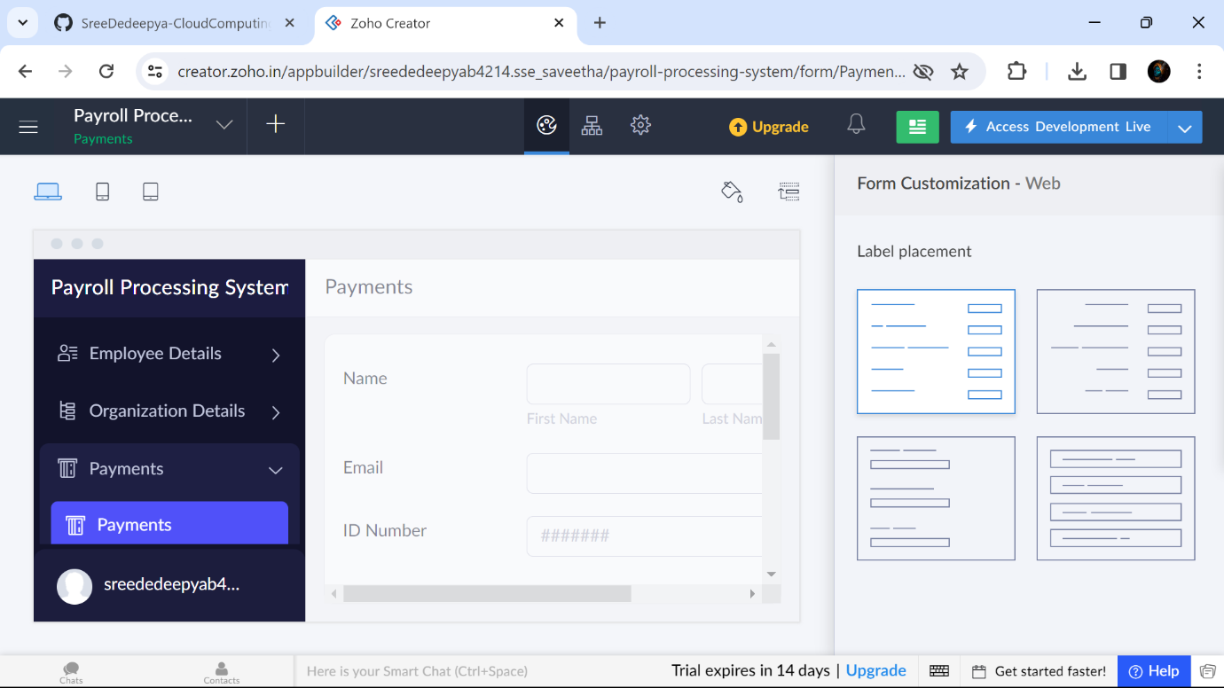

Step5:Displaying all Employee Details

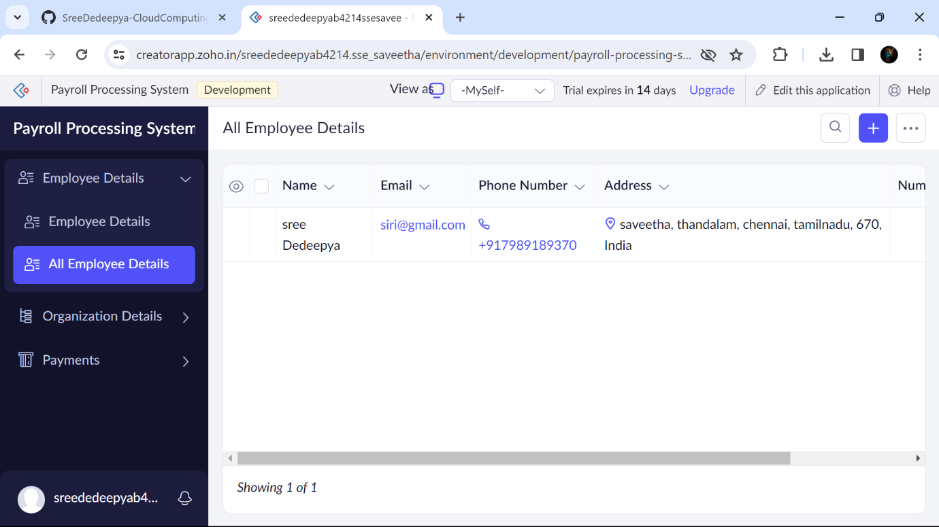

Step6: Displaying all Organization Details

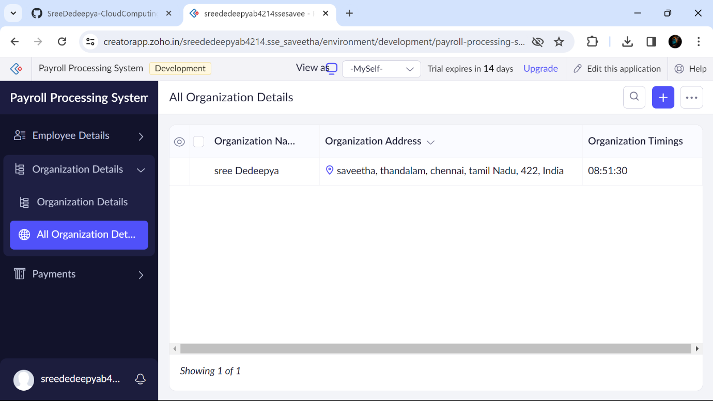

Step7: Displaying all PaymentDetails

